EIGRP

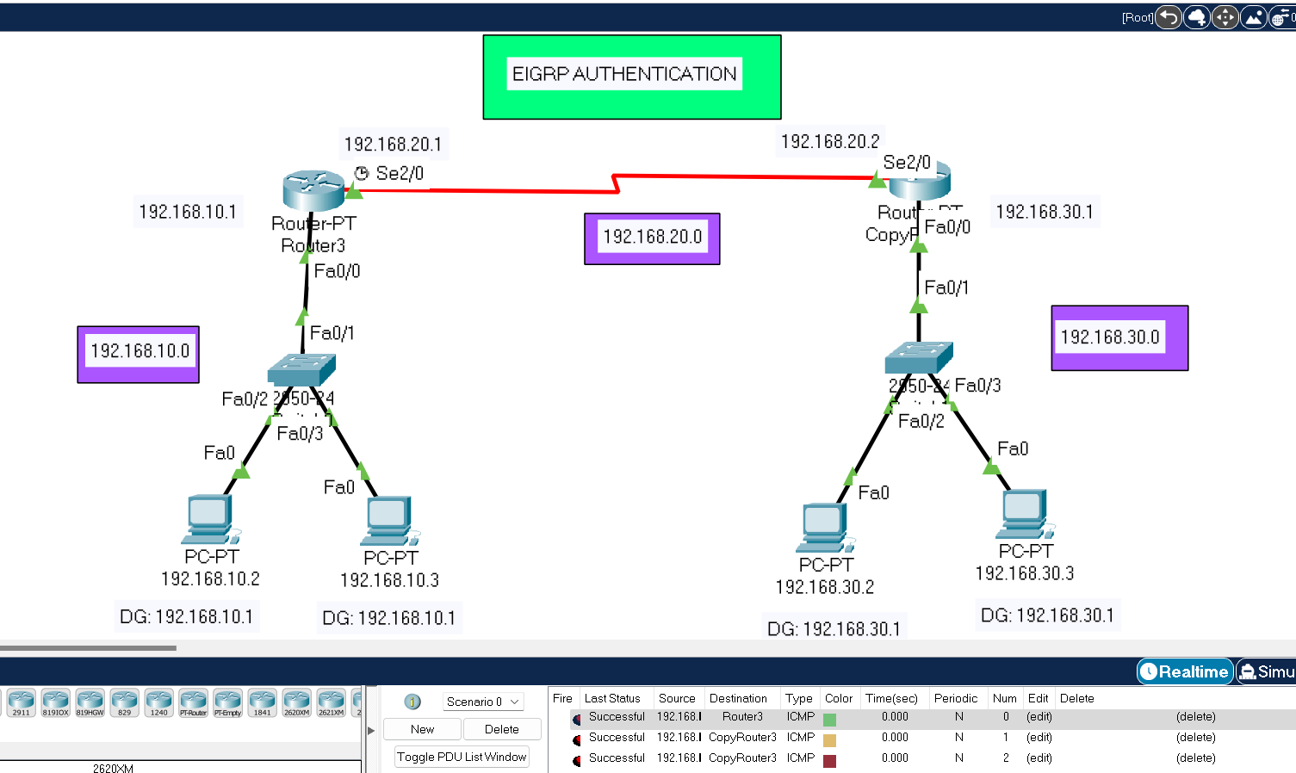

ROUTER 0

Router# en

Router# config t

Enter configuration commands, one per line. End with CNTL/Z.

Router(config)#router eigrp 10

Router(config-router)# network 192.168.10.0 255.255.255.0

Router(config-router)# network 192.168.20.0 255.255.255.0

Router(config-router)# exit

Router(config)#exit

ROUTER 1

Router# en

Router# config t

Enter configuration commands, one per line. End with CNTL/Z.

Router(config)#router eigrp 10

Router(config-router)# network 192.168.30.0 255.255.255.0

Router(config-router)# network 192.168.20.0 255.255.255.0

Router(config-router)#

%DUAL-5-NBRCHANGE: IP-EIGRP 10: Neighbor 192.168.20.1 (Serial2/0) is up: new adjacency

Router(config-router)#exit

Router(config)#exit